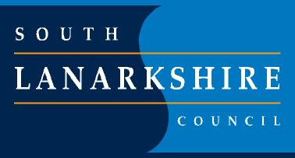

Machanhill Primary School and Nursery Class

“ Promoting SAFETY, SUCCESS and RESPECT to ensure all children can thrive and “Be the BEST they can BE.”

SAFE , SUCCESSFUL, RESPECTFUL
2026-2027
Our priorities for session  2026 – 2027 | Writing:  We will improve children’s writing skills across the school by using consistent approaches and supporting staff with training. | Numeracy:  We will improve children’s numeracy skills through consistent teaching approaches. We will carefully track children’s progress so that we can provide the right support and challenge to help every child succeed. | Positive Relationships:  We will help children understand bullying, conflict and positive relationships through development of a consistent programme of learning. We will also work with parents by sharing information and resources so that home and school can work together to support children.
What we will do to help achieve our priority. | Teachers will take part in training to develop their understanding of different types of writing and how best to teach them. They will use this learning in class and have opportunities to visit other schools. Senior leaders will monitor progress, review children’s work and gather feedback from pupils and staff. | We will review how we assess and track children’s numeracy progress and introduce consistent approaches across the school. Teachers will receive training and support to assess learning effectively. Regular meetings will help us identify children who need additional support or challenge. We will monitor progress through classroom visits, planning and discussions about children’s learning. | We will listen to pupils, staff and parents to review and improve our anti-bullying policy and approaches. We will provide consistent lessons on bullying, conflict, online safety and positive relationships.  Staff will model respectful behaviour and use our school values and UNCRC to support children to make positive choices. We will also offer parent workshops and helpful information to support families.
How will we know?  (Measures) | More children will achieve their expected level in writing. Children will be more confident, engaged and able to understand how they can improve. Teachers will feel more confident teaching writing, and teaching approaches will be consistent across the school. | Children will become more confident and successful in numeracy. Consistent teaching approaches will be evident across classes, with children’s work showing progress and clear next steps. Teachers will use assessment information to identify gaps early and provide the right support or challenge. More children will make appropriate progress and achieve their expected Curriculum for Excellence level in numeracy. | Children will show a better understanding of bullying, conflict and respectful relationships. We will see this through pupil conversations and regular wellbeing surveys. Parents will feel more confident supporting their children. We will have clearer records of bullying concerns and their outcomes. Feedback from pupils, parents and staff will help us identify strengths and further develop positive relationships across our school community.

