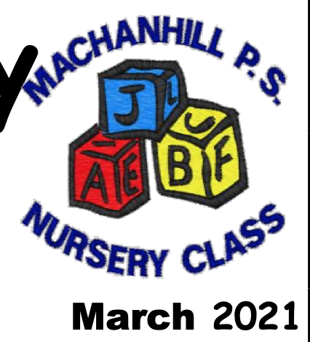
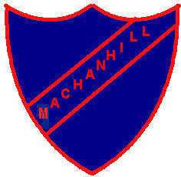
Machanhill Primary
Newsletter
Happiness, Achievement, Respect, Knowledge February 2024

Dear Parents/ Carers,
Welcome to our latest newsletter filled with news about school events. It has been a busy few weeks with Room 12 visiting the Glasgow Science Centre as part of their sustainability project. They are working in partnership with the Clyde River Foundation.

Our Athletics team had great success at the Larkhall Indoor Athletics final and are now headed to the Lanarkshire Finals this Friday. We wish them lots of luck.

Primary 7 children had a visit from colleagues at Larkhall Academy as an introduction to our P7-S1 transition programme. They had the opportunity to talk to secondary staff about life at secondary school.

Staffing
Last week we welcomed a new depute head teacher to Machanhill Primary School. Mrs O’Neill joins us as DHT for Nursery and P1-3. She will be working closely with Mrs Carson getting to know all the children and families. Mrs Tallamy will have departmental responsibility for P4-7 and will also be the lead contact for ASN within the Nursery and school.

Mr Smith returns from paternity leave this week and will resume his duties as class teacher in Room 8. He is a proud dad to a beautiful little boy who was born during the Christmas holidays. Thank you to Miss Dunn who taught Mr Smith’s class in his absence.

Mrs Hamilton continues to be the class teacher in Room 10. We hope to welcome Mrs Kellachan back to school soon. Miss Walker will continue to have responsibility for Room 4 on a Monday and Tuesday but will be allocated to another school for the end of the week.

Finally, we are also saying goodbye to Mrs Paton who has secured a new position within the local authority. Mrs Paton will continue to work in the school office until Wednesday 28th February. We wish her much success in her new venture.

Young Leaders of Learning
On Wednesday 24th January eight p5 and p6 ambassadors visited local authority headquarters and participated in training to become Young Leaders of Learning, as part of an Education Scotland initiative. The purpose of the programme is to help children and young people to be more actively involved in helping to improve their schools by: Taking part in reciprocal visits to other schools to identify what is working well, areas for improvement and effective practice. Over the next few months, the children will be liaising with and visiting Crawfordyke Primary School in Carluke.

New P1 Entrants – August 2023
We are delighted to have 29 children enrol for school at Machanhill Primary in August 2024.
If your child is due to start school in August 2023, applications for admission should be made on the South Lanarkshire website. To do this, you must have your child’s birth certificate and two proofs of address to submit as part of the application. Guidance for placing requests can also be found on the website.
If you haven’t already enrolled your child, applications can be made by clicking this link:
https://www.southlanarkshire.gov.uk/info/200186/primary_school_information/392/enrolling_your_child_for_school

Weather Ready!
Please make sure your child comes to school or nursery appropriately dressed for the cold weather. Nursery children are encouraged to bring a change of clothes. We recommend, jacket, puddle suit, wellies hat, scarf and gloves for our nursery aged children. School children should have a warm jacket and suitable footwear for the weather.

Gym Shoes
Please send your child with indoor shoes. These should be black gym shoes or trainers with non-marking soles. All children are expected to change into indoor shoes and these should be left in school.

Lost Property
A huge number of items have been left in lost property since August. If your child has lost anything, please visit the table at the school entrance to retrieve it before the February holiday. On Wednesday 14th February we will donate any leftover items to charity.

Allergies
To ensure the safety of all our children I’d like to remind you that school is a nut free zone. Snacks and packed lunches should not contain nuts or products containing nuts. This includes Nutella and Kinder Bueno snacks as examples.

Lockerbie Manor Residential Excursion for P7
Mr Marley, Mr Hamilton, Mrs Hamilton, Mrs Johnson, and Mrs Tallamy will be the adults taking our P7 children to Lockerbie Manor. The children in P7 who are not attending will remain in school with Mrs Kellachan. Children should bring their case to school in the morning at 9am. Medicines should be handed to a staff member in a plastic sandwich or freezer bag with the relevant form completed. The children will leave at approximately 1.15pm and parents are welcome to come to school and wave the children off. Please remember that waterproof jackets, trousers and boots should be put on the top of the case for easy access when your child arrives at the centre.

Uniform
We are proud of our school uniform and encourage the children to wear uniform daily, including in inclement weather. All children should wear a pale blue shirt and tie or pale blue polo shirt with the school sweatshirt / cardigan or royal blue jumper. Skirts and trousers should be grey. Black or navy leggings and jogging trousers are not school uniform.

Mobile Phones and Smart Watches
Mobile phones and smart watches are expensive items and risk getting broken or damaged at school. If your child needs to bring these items to school, they will not be allowed to use them and they should be powered off in their school bags.

Nursery

Donations
Our nursery and P1 children are looking for donations of items that you no longer require, and they can make use of. Items include, plant pots, seeds, small electrical items, old tools, buttons, ribbons, boxes, wine corks, twigs, stones, small world toys like dolls, cars and people who help characters. Any donations would be welcomed and can be handed to nursery staff or given in at the school office. Please ask the nursery or P1 ladies if you are unsure.

Important Dates

Monday 5th February – Nursery Photographs
Tuesday 6th February – Barnardo’s, Chill Chat Coffee 2pm – parents welcome
Wednesday 7th February – P7 Footballl Festival at Larkhall Academy – Parents Welcome. 12.30pm
Thursday 8th February – Room 8&9 visit Bannockburn
Friday 9th February- P7 Athletics Final at John Wright Sports Centre East Kilbride 10.30am.
Monday 12th February – HOLIDAY
Tuesday 13th February – HOLIDAY
Wednesday 14th February – IN SET Day – School closed to pupils
Monday 19th February – P7 Lockerbie Manor Residential visit.
Enterprise ad Careers Week
Parent Council Meeting 6.30pm
Parents’ Feedback Form
Pupil Name: _______________________ Class: ______________
Suggestion / Feedback:

Signed: __________________________

